Generative AI HW5 電機四 4111064113 白舜文
I . Problem Description
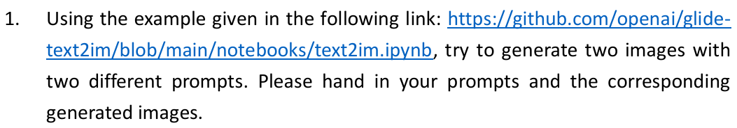
II. GLIDE results running on Google Colab
prompt = "A snowman with a red scarf and a black hat."


prompt = "A horse is eating the grass."
